**VSCode Timeline-**

Visual Studio Code allows you to see a timeline of pushes you do on GitHub. So, it allows you to see previous changes from previous push requests. It also shows you how long ago they were pushed. It brings up a side by side view of the old code and the new code. It highlights the lines that have been updated along with the code itself being updated.

**-Tutorial-**

Assuming that you already have a project folder and github desktop installed, we will start. Open vscode, go up to file, and select open folder. Navigate to where you have your project and select it.

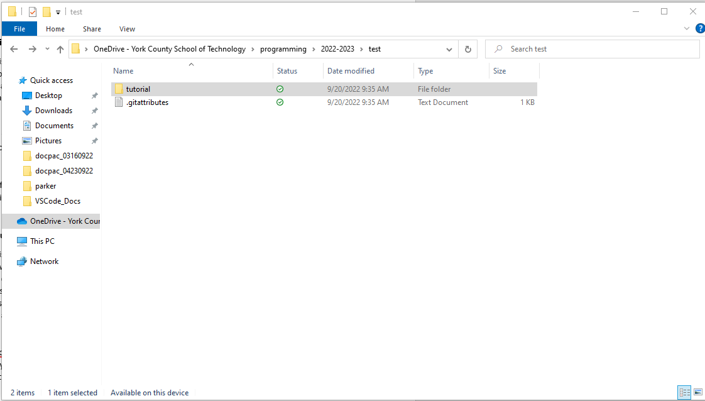

Once the folder has been added to vscode, go down to timeline and select it. You should see a list of all your previous pushes and their names along with when they were pushed. A file needs to be selected for the timeline to function correctly.

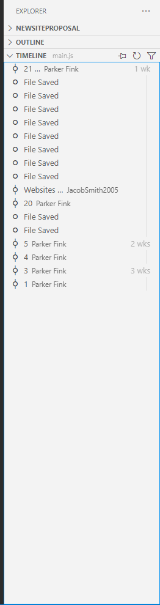

**VSCode Built In Terminal-**

Visual studio code also has a built-in terminal. This allows you to interact with your code and compute without having to have Command prompt open. The terminal allows you to have multiple terminals open along with having a debug console, an output console, and a problems console. This feature also allows you to hotkey your way between multiple open consoles, along with showing you what consoles you already have open. When in list mode, you can change the color of specific open terminals and even change the names to them for other projects.

**-Tutorial-**

Have VSCode already open. At the top of your screen select Terminal, then select New Terminal. Or hit the hotkey ‘Ctrl+Shift+`’. At the bottom of your screen you should have a powershell/terminal box. If you select the ‘+’ button, it will create a new terminal for you to switch between.

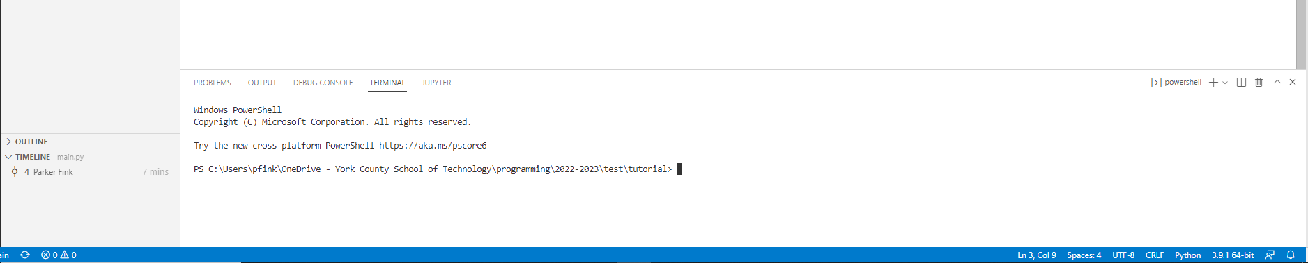

To change anything about your terminals, you select the drop down box next to the ‘+’. Next you select which terminal you want to edit, and right click.

in our case, we have three separate terminals already opened. We have one renamed, one with a changed icon, and one with a changed color. To change any of these you right click on the selected terminal and left click on either Change Color, Change Icon, or Rename to do their respective task.

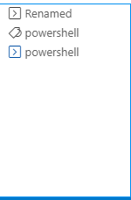

**VSCode Built in Map-**

Visual studio code utilizes a minimap in the corner to show you a mini version of your code. It aids in getting a good handle on how big or small your code is. Atom has this feature along with the terminal but those are both add-ons that you have to install later, VSCode comes pre installed with these. The mini map allows you to select where you want to go in your code and scroll with the map, that helps greatly with larger files due to the minimap scrolling being infinitely faster than regular scrolling. The map also shows you a highlighted line of where your cursor is in relation to the rest of the code.

**-Tutorial-**

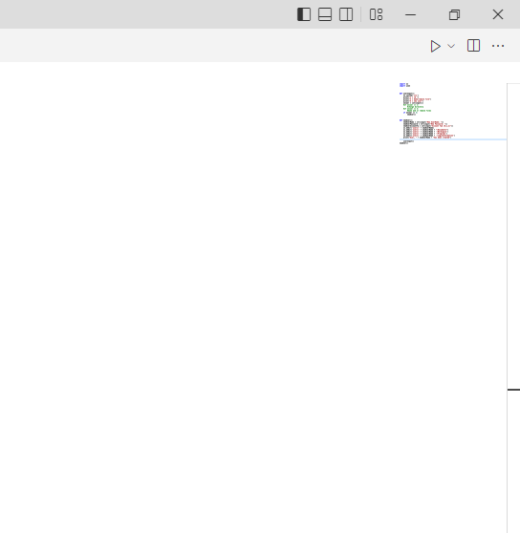

When you hover above the map a highlighted box appears showing where that area is selected. Here you can click, hold and scroll with the mouse to scroll up and down your page. You can also see error lines from this map along with a highlighted line that you are currently on.

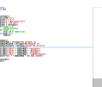**VSCode File Icons-** I am fairly sure Atom has this as well but once again it is an add- on. In your file tree, vscode shows an icon that correspond to the file. So HTML files show a little <> icon, pictures show a picture icon. As of now im not entirely sure what else they do but they are nice to have.